Direct Satellite Connectivity - Research & Trouble Shooting

Bridging the Digital Divide

Unit: COIT13236

Group: G06-DST-UG25T2

Student 1: Shahriar Haque - S0259035

Project Mentor: Ahmad Saeed ([a.saeed@cqu.edu.au](mailto:a.saeed@cqu.edu.au))

Date: 31-08-2025

CQUniversity Australia

GitHub Repository: <https://github.com/cquict2025/nis-y25t2-project-g06-dst-ug25t2/tree/main>

Raspberry Pi5 Mesh Router x Starlink Satellite

# Introduction

The aim of this is to give the Raspberry Pi direct Satellite connectivity remotely via a Starlink Antennae without the use of the Starlink router.

The idea is to run a different interface that bridges the gap between Starlink and OpenWRT which can be found at <https://github.com/xpistarlink/StarlinuX> .

If the Starlink Router can be removed from the system and entirely replaced by the Pi5, the overall system will also be saving around 9w of power too.

# Setup

**Software Setup Groundwork:**

The mesh router will first have to be flashed with OpenWRT and using default logins 192.168.1.1 as this is what the application requires.

**Additional Physical Setup Requirements:**

30v PoE Adapter

Starlink Satellite Dish

30v PoE Ethernet Cable

**Connecting Pi5 to Satellite:**

However, the minimum requirements to getting the satellite connected without the Starlinux application are,

1. Enabling Wireless Radio or Having an Ethernet adapter to connect your management device to the Raspberry Pi5
2. Create Ethernet Wan Connection
3. Plug Satellite into Starlink Router
4. Set Starlink router to bypass mode via Starlink mobile application
5. Connect router to mesh via ethernet cable, connecting to the Raspberry Pi5’s Wan Port

**IF the Starlinux application is installed:**

Via the instructions on the [GitHub repository](https://github.com/xpistarlink/StarlinuX), you can connect the satellite to compatible POE injector then from the injector to the Pi5. This aims to replace the power hungry Starlink router with a lower consumption POE injector.

# Testing

TESTING + IMPLEMENTATION:

Once flashed and logged into your device, you must install the StarlinuX application to the device by running two commands, one runs the first script “first.sh” and the next runs both “second.sh” and “third.sh” from the auto install section of the github repository.

During testing I ran into an error which fed back as “ash: local: line 5: not in a function.

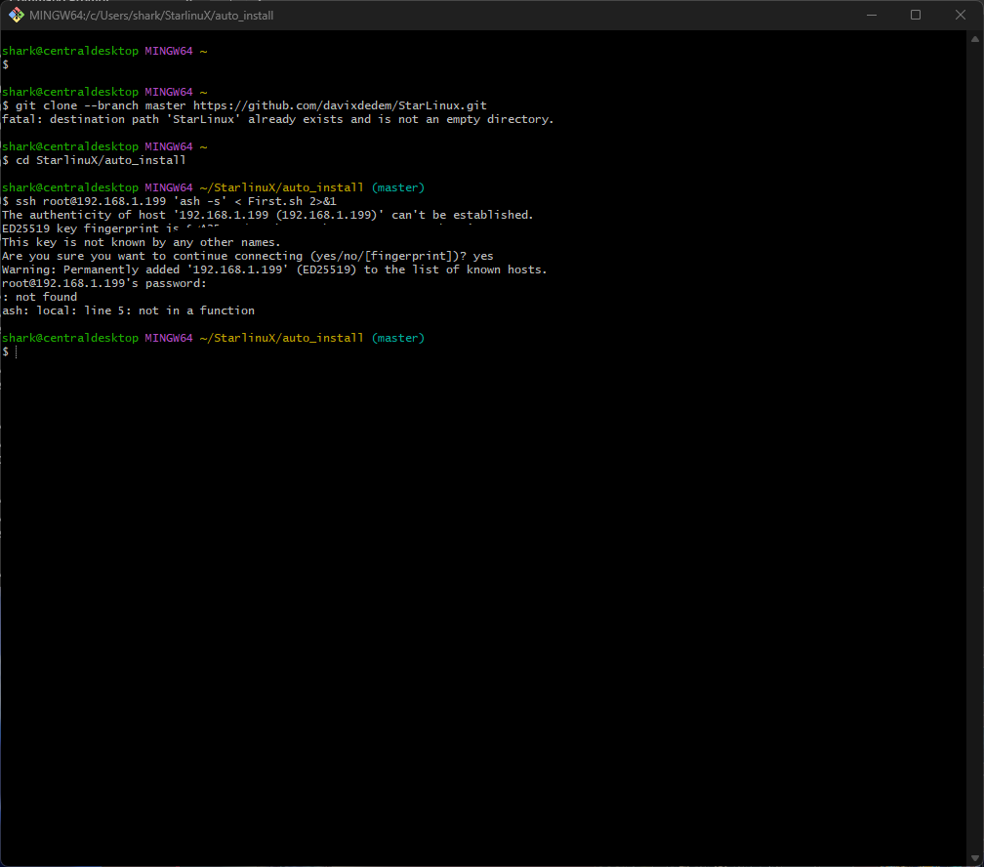

Which upon further inspection of the script it was trying to run found that it refers to the model of the device “local model=$(cat /proc/device-tree/mode) which is due to the custom OpenWRT image that is being currently run on the device.



To fix this the Pi5 it was recommended that it needs to be freshly flashed with the correctly supported version which is 24.10.2 of OpenWRT which can be found at <https://openwrt.org/releases/24.10/notes-24.10.2> .

Just to make sure it wasnt a syntax error, i manually added the model in as such “check_sbc_model() { local model=$("Raspberry Pi 5 Model B Rev 1.1") echo "Detected model: $model" band="2g" }” and still to no avail.

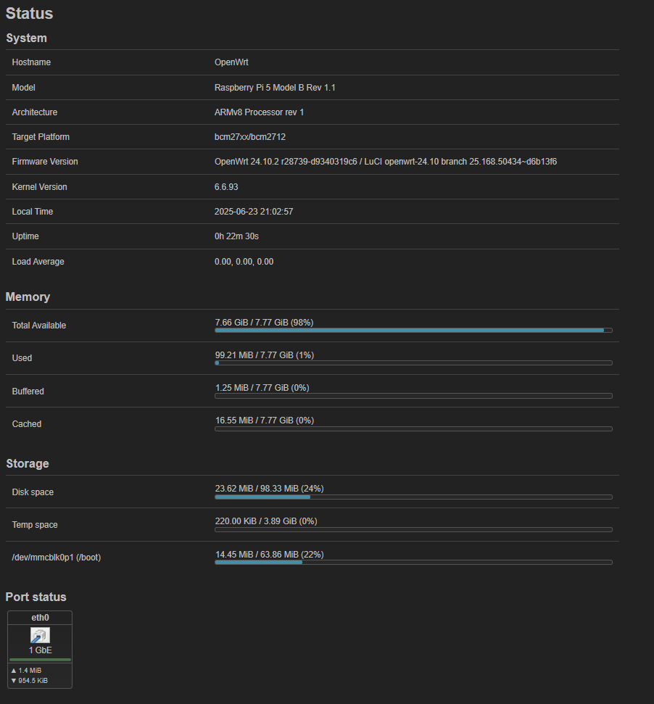

However, even after doing so I still was reaching the same error. Post flash the device could no longer ping 1.1.1.1 or 8.8.8.8 which heavily implied DNS issues.

Although running the OpenWRT device as a router and connecting the laptop to it proved that there is no issues with the connection and the device is getting interenet fine.

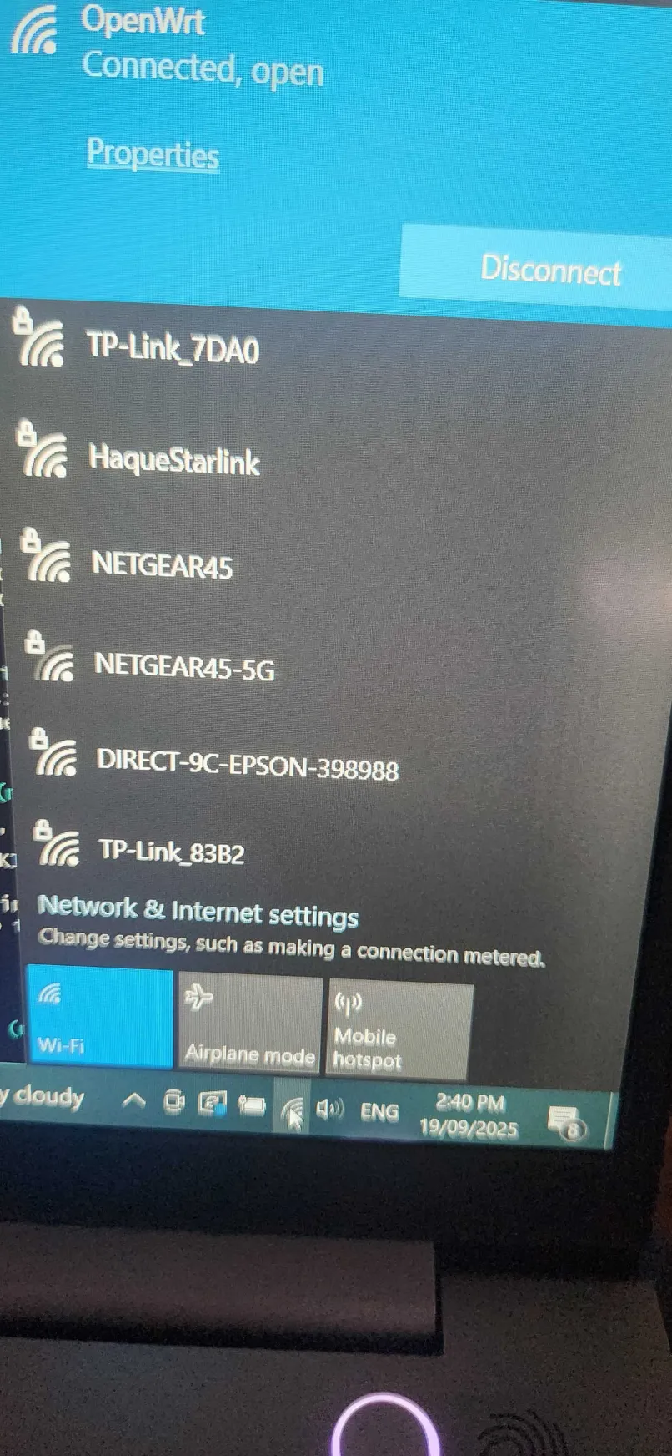h 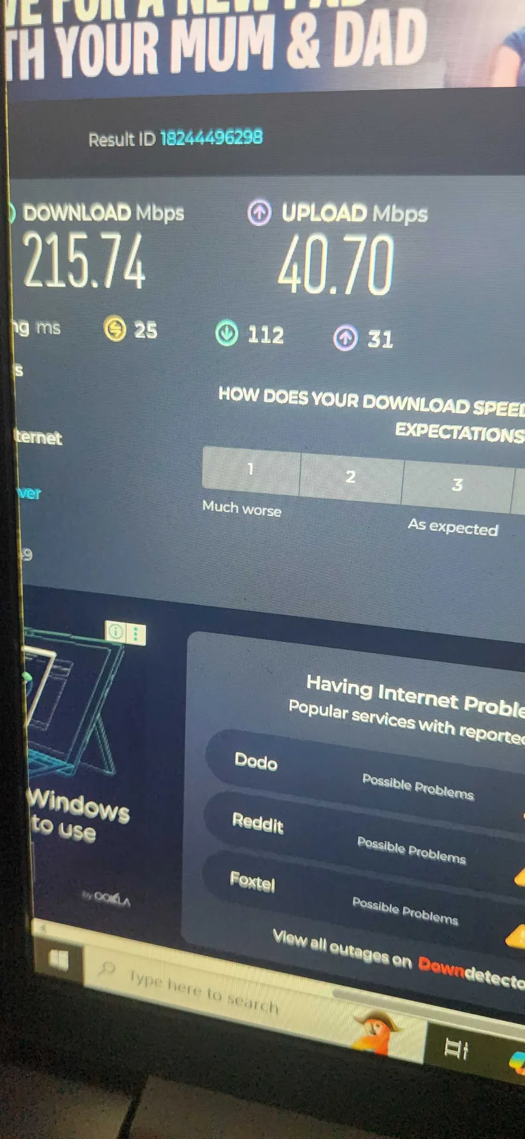

It was then flashed, and the network ports were setup differently with the laptop connecting via SHH on the Pi5’s wireless radio,

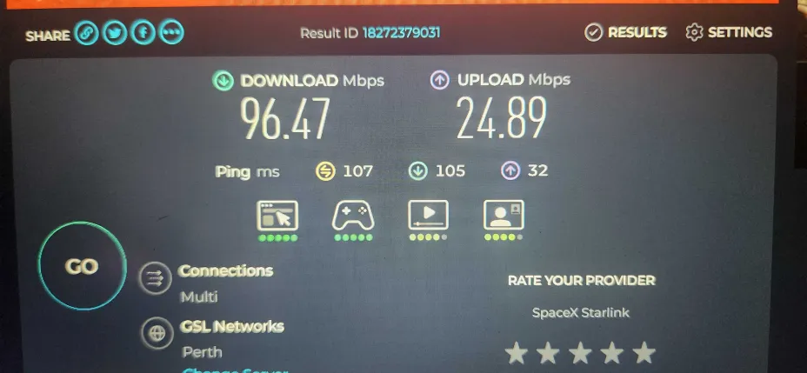

Which in comparison to a direct connection to the starlink via the laptop: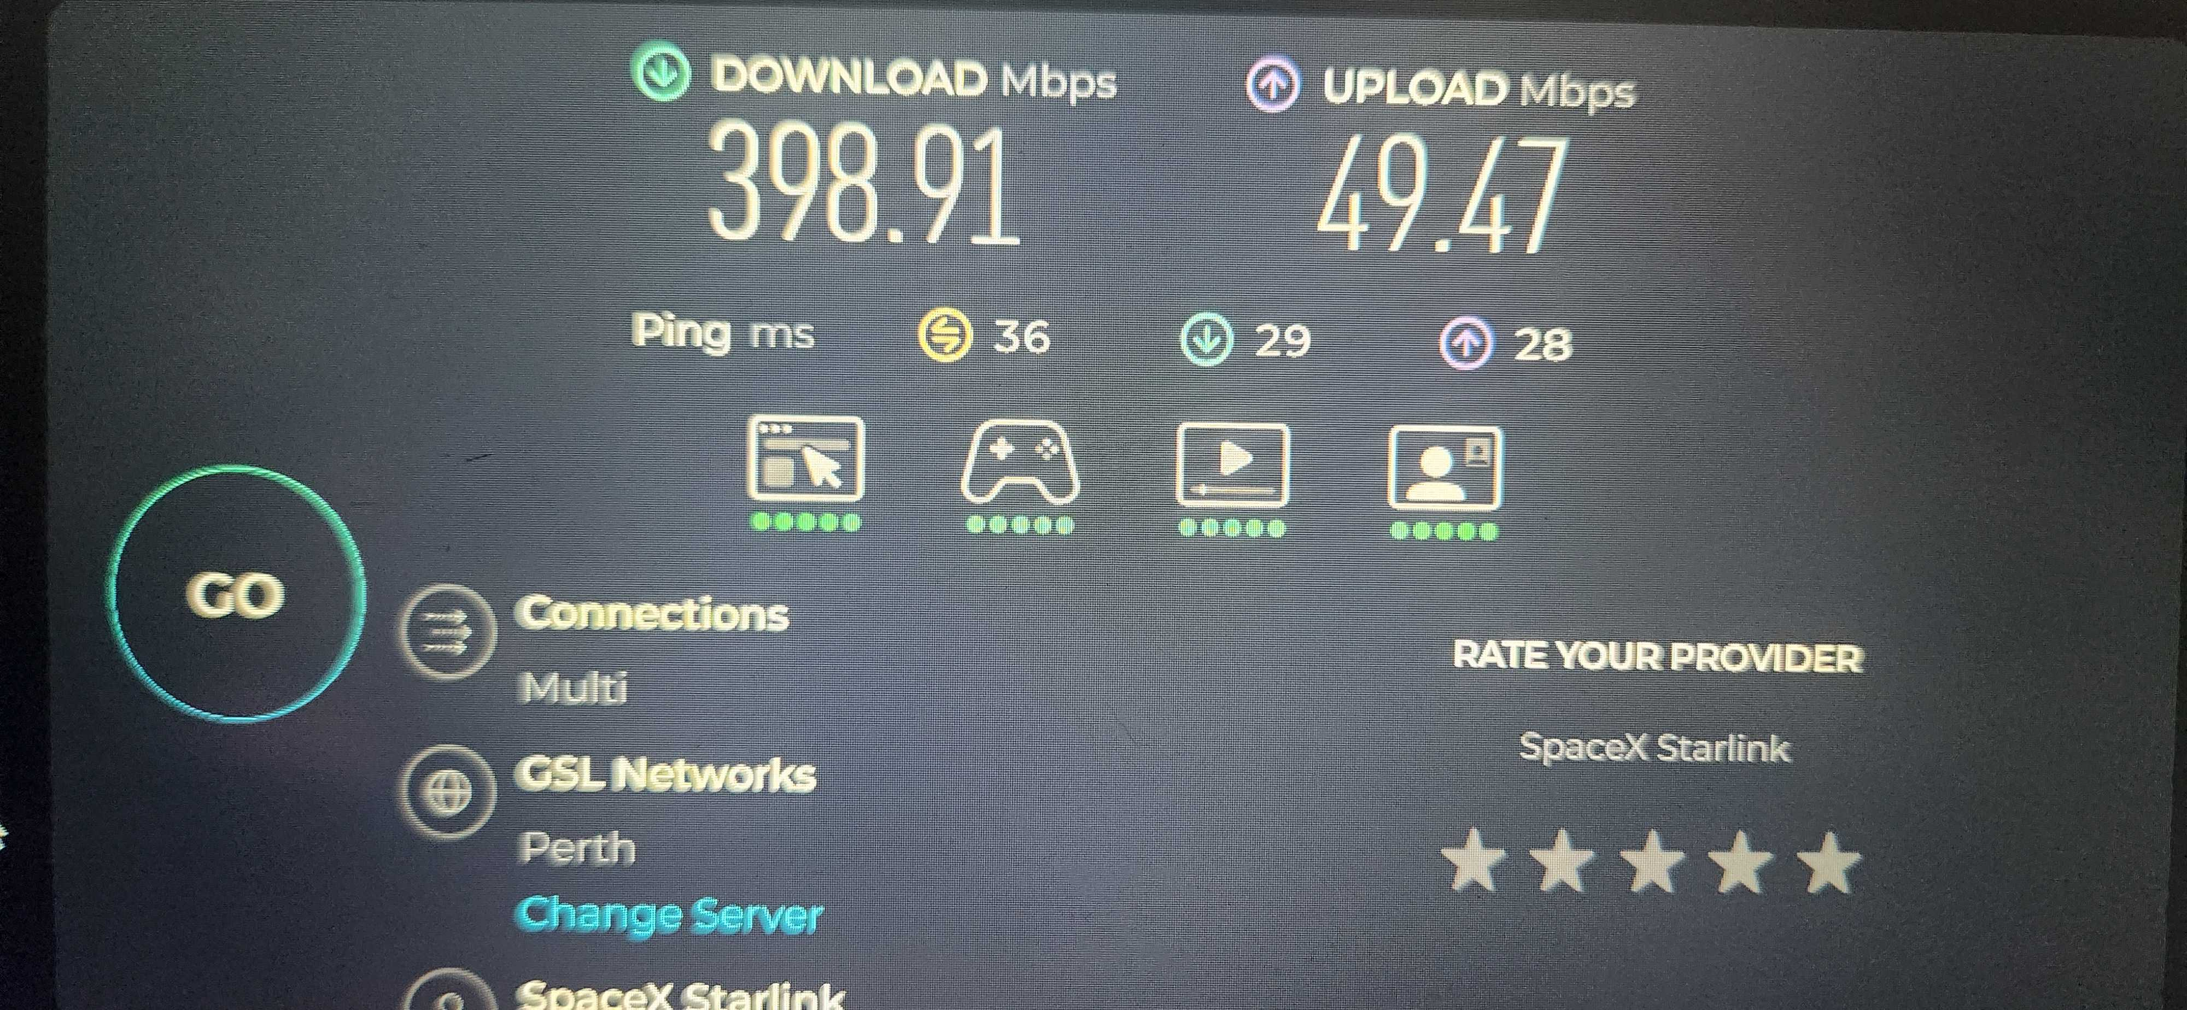

Implied that the network download was performing at 25% of total speed and the upload was performing at 50% total speed.

Implying the wireless radio was a definite bottleneck in the system and would need to be replaced or bypassed.

With the setup back to defaults, running the starlinux install was still to no avail and returned the same error.

Sadly, it seems that the Pi5 is currently not compatible with the software required.

Maybe with time a work around may be able to be found out to implement the Pi5 with a star link satellite.

Further testing was then done to determine if it was able to run it using the bypass mode on the Startlink setup, effectively disabling the router and using it as a PoE supply for the satellite and there was mild success, even without getting the application to run, the mesh router was able to establish a network connection.

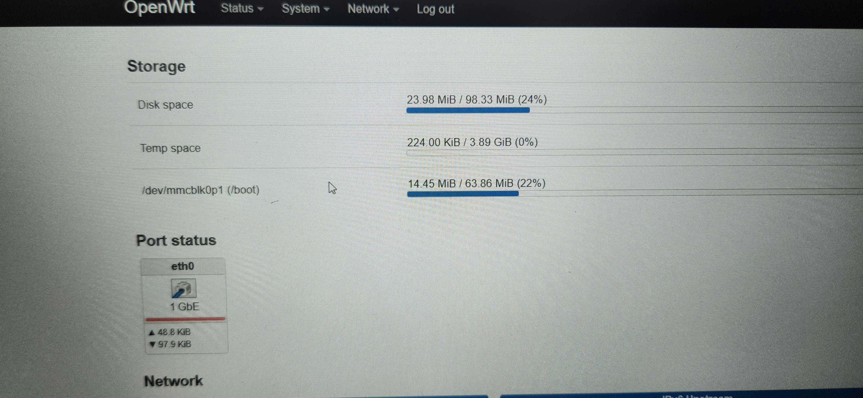

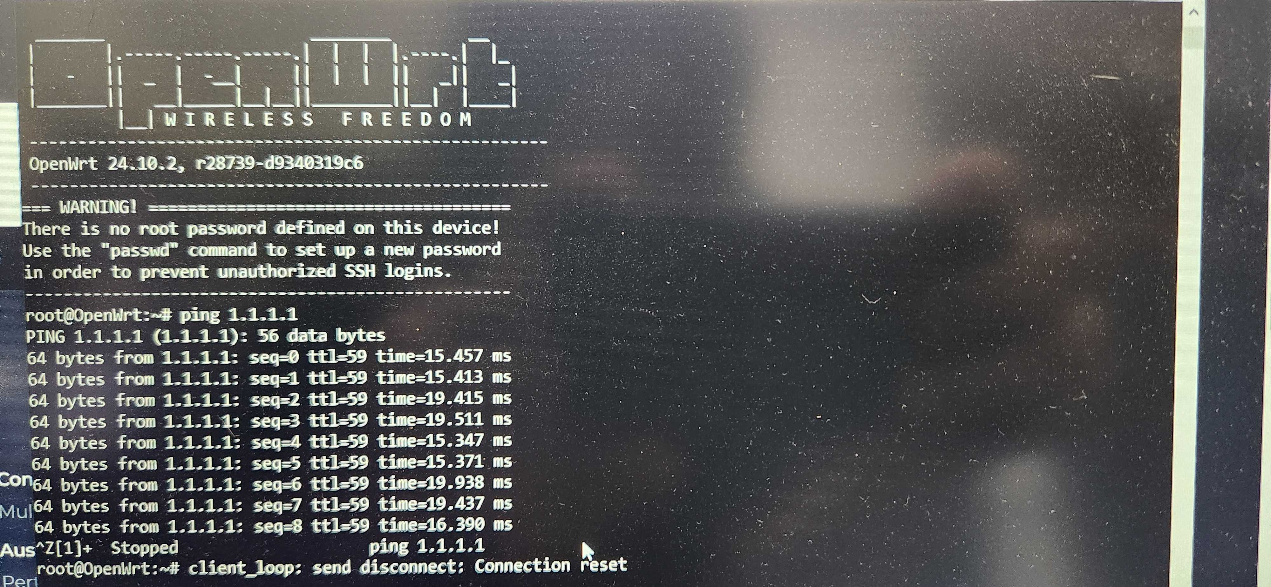

Power Notes:

Once installed the next step was to try connect the Pi5 to the satellite dish itself rather than through the router. The ethernet from the satellite was then plugged into the Pi5 directly via WAN point.



This still yielded no results as the satellite had no external power source and was powered directly over the ethernet from the Starlink product router itself.

This is then mitigated by running a PoE adapter:

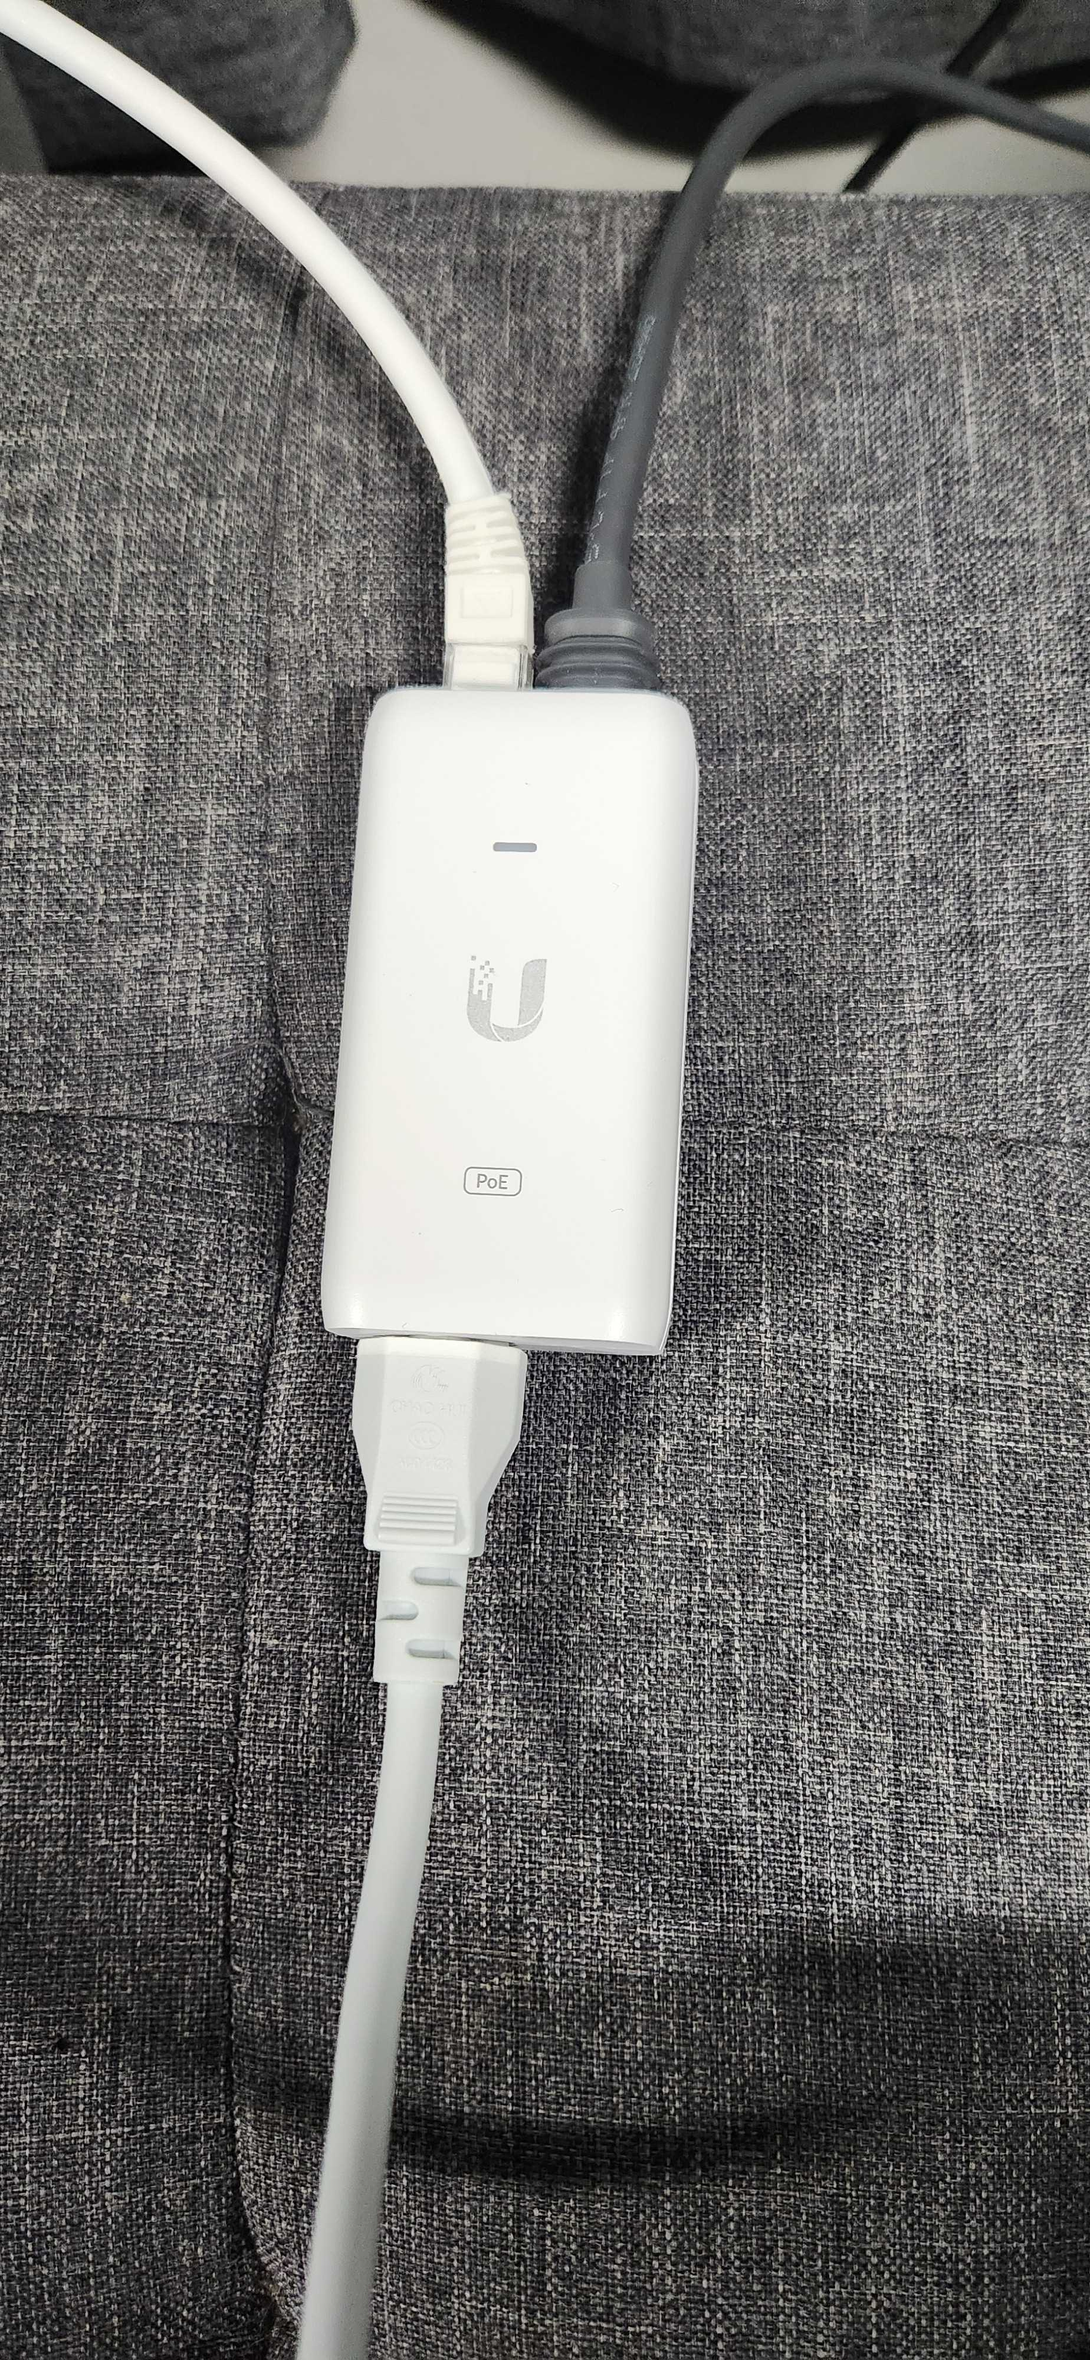

The right-hand cable being the satellite and the left being to the Pi5. There is still no connection, and the light is not lit up, implying that there is a power delivery issue or shortage. The PoE adapter is a 48v and should be sufficient for the satellite from Starlink.

However, the light is meant to be lit up like in the example bellow:

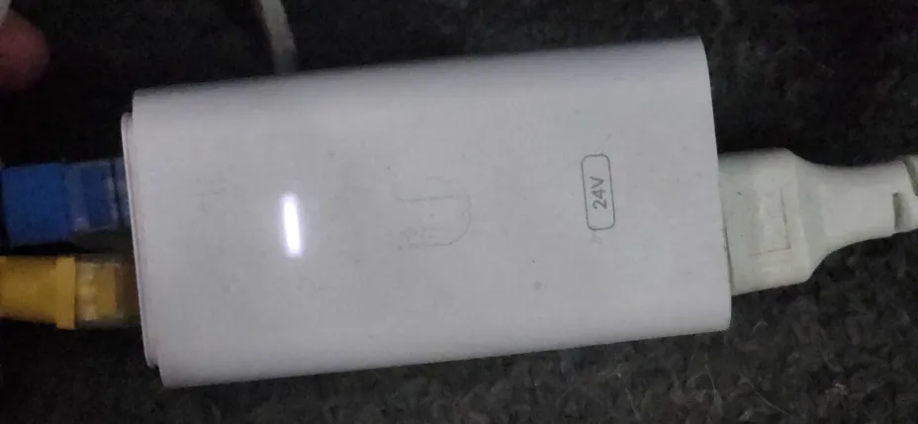

The above image is of my other home network for a local mesh tower and shows its active connection.

Which creates a scenario where it goes from Dish to Adapter to Pi5 to give sufficient power to the Satellite dish. The previous star link router did not need this as it had it inbuilt. Also, the cable to the dish must be a 30v PoE, Cat6 Cable.

As the power draw from the satellite dish is quite hefty at on average 50w for the dish. As the Power adapter will be covering the satellites draw, the power the Pi5 itself will be unaffected and double checked with testing has proven that the draw remains at 5w under full load.



from the in app , or from the plug with the router in bypass mode:



Without Bypass Mode:



Which means the Router is roughly drawing around 15w of power.